Forensic Investigation Report
Case no: 001
Report prepared by Sneha Yadav
Report date: 2025/29/12
University ID: 24071275
CONTENT
- Introduction

- Scope of Investigation

- Tools Used

- System Profiling and User Analysis
4.1 Operating Timeline
4.2 Operating System Details
4.3 Time Zone Information
4.4 User Analysis

- Image and Media Evidence Analysis
5.1 Stalking of Christina Detsiwt
5.2 Stalking of Sabrina Dewercs
5.3 Meetup Between Sabrina and Christina
5.4 Reflection of Stalker in Media Evidence

- Email Analysis
6.1 Analysis of Alleged Suspect’s Email
6.2 Analysis of Victim’s Email
6.3 Analysis of Emails Between Victim and Suspect

- Instant messaging tool Analysis

- Findings and Interpretation

- Conclusion

- Hash Verification

- Appendices

- Introduction.
This report gives a background information about the findings of a digital forensic investigation conducted as part of a suspected stalking investigation. The examination concentrated on analyzing the digital contents within the forensic image file namely: “Hunter XP for Dongled v6E01_1”. The objective of this report is to preserve and identify any evidence that can be used for legal consideration. Most focus was given on maintaining the forensic integrity while analyzing system artifacts, user data, and OS information.

- Scope of investigation.
The forensic examination lasted approximately 81 hrs. on 02/12/25-29/12/25, focusing on the analysis of .E01 evidence titled “Hunter XP Dongled”. A range of forensic tools were used in the examination like Autopsy, RegRipper, FTK imager, Event Log Explorer, Registry viewer.

Each forensic tool that was used served a specific purpose: Autopsy assisted in examining system artifacts, FTK imager extracted the hives and Registry viewer revealed Operating System configuration. This multi-tool examination ensured that the evidence was examined thoroughly and in accordance with the already established forensic principles.

- Tools Used
- Autopsy 4.22.1
- AccessData FTK Imager 4.7.3.81
- AccessData Registry viewer 1.8.0.5
- RegRipper 3.0
- Ophcrack 3.7.0
- Event Log Explorer 5.7

- System profiling and User Analysis
To understand everything about “Hunter XP Dongled”, a system profiling was done using forensic tools to collect system-related data, from Operating system registry. The registry acts as a database containing user settings, configuration data, and system-level information. By examining registry data, details related to system setup and user interaction were identified, giving a pattern and hint for future findings.

  - Operating and Timeline:
Analysis of registry keys related to the operating system showed some vital information, including the product name, product ID, operating system version, and installation details. These findings are useful to establishing a timeline and understanding the system usage.

The system was identified as running Microsoft Windows XP, installed on 28th February 2002. The registry data also recorded timestamps after shutdown, which can assist in relating to user related activity. Such data is particularly important when evaluating events linked to alleged crime.

OPERATING SYSTEM INFORMATION (system artifacts)
Product name | Microsoft Windows XP
Product ID | 55277-005-6418583-21673
Current Version | 1.511.1
Registered owner | Bob Hunter
Registered Organization | PC User Company
Install Date | February 28, 20002, 22:02:39
Shutdown Time | 2002-0228 22:02:02 UTC

  - Operating system Details
A file system in use was found to be NTFS, an important factor in forensic examination. This is important because it affects how the timestamps on files are kept, which helps in interpreting correct order of events related to the alleged crime.

  - Time Zone Information
Further examination confirmed that the NTFS file system stores timestamps in GMT.
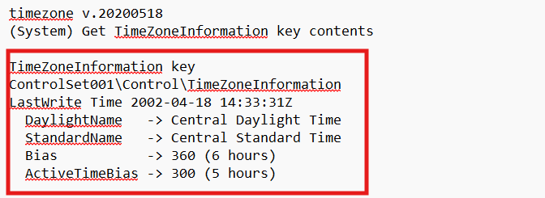
(Figure 1)
This information was revealed on the system’s time zone settings, which is crucial for interpreting and aligning the timestamps related to the events that allegedly occurred. To ensure the consistency, time zone were adjusted within Autopsy so that recorded events aligned with system’s local time. This adjustment was important to maintain during timeline reconstruction.

  - User Account Analysis
User account information was retrieved from registry data to identify individuals who had access to the system. Various user accounts were discovered, including standard users and administrative accounts. These findings are summarized in Figure 2.1 and 2.2.
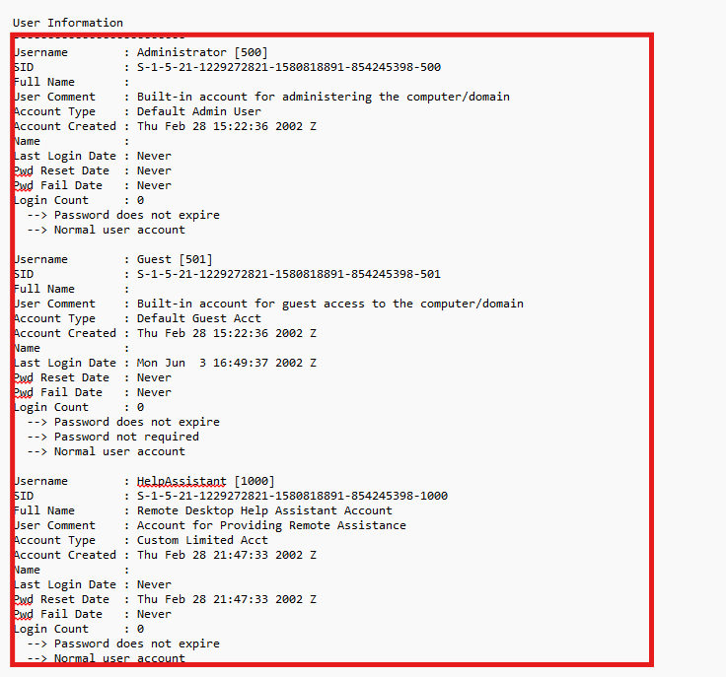
(Figure 2.1)
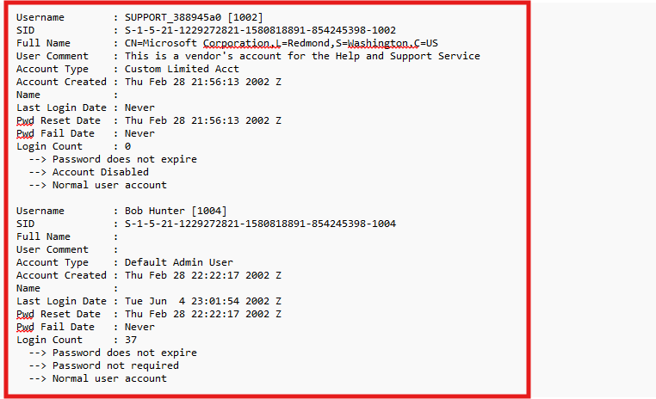
(Figure 2.2)
User Account analysis is an important part of digital forensics, as it helps to determine which and when users interact with the system.

- Image and Media Evidence Analysis

  - Stalking Christina Detsiwt
Recovered image file shows that Christina Detsiwt was under surveillance. Metadata analysis confirms that the image was captured using a Canon PowerShot camera.
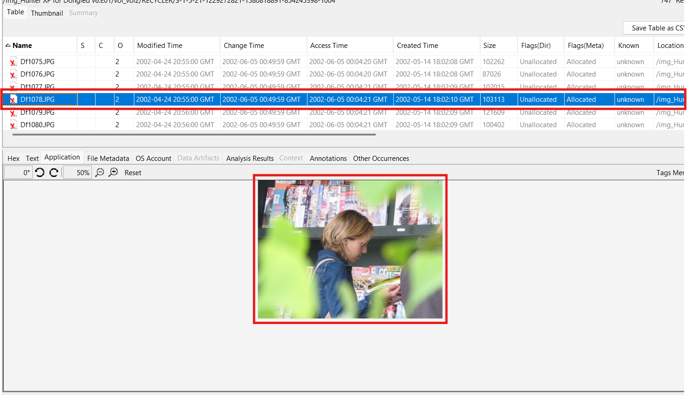
(Figure 4.1)
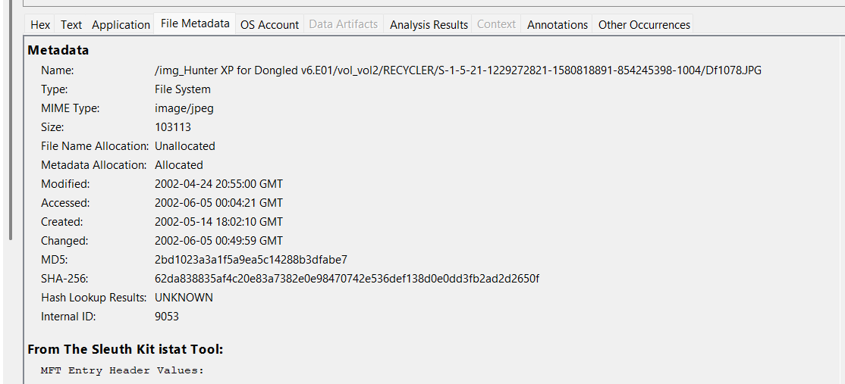
(Figure 4.2)

  - Stalking Sabrina Dewercs
More images show similar surveillance activity involving Sabrina Dewercs. The same camera device was used which links the incident.
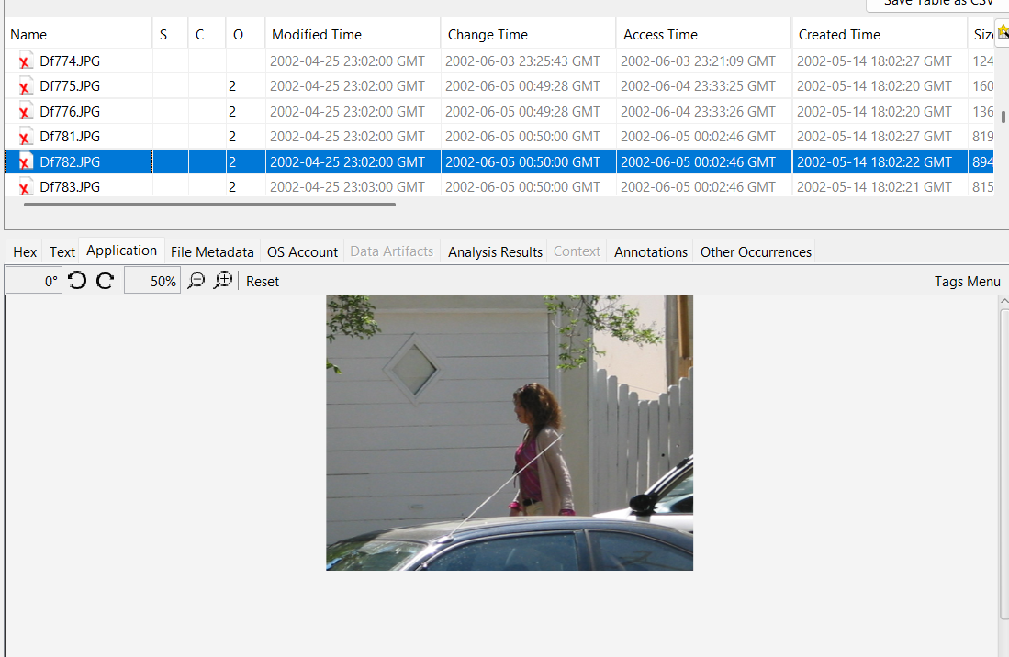
(Figure 5)
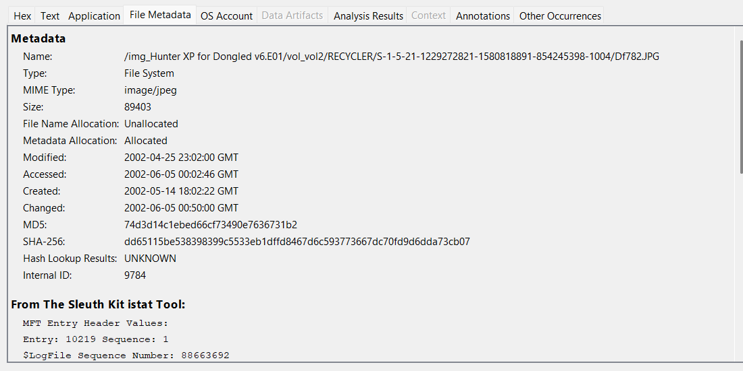
(Figure 5.1)

5.3 Meetup Between Sabrina and Christina
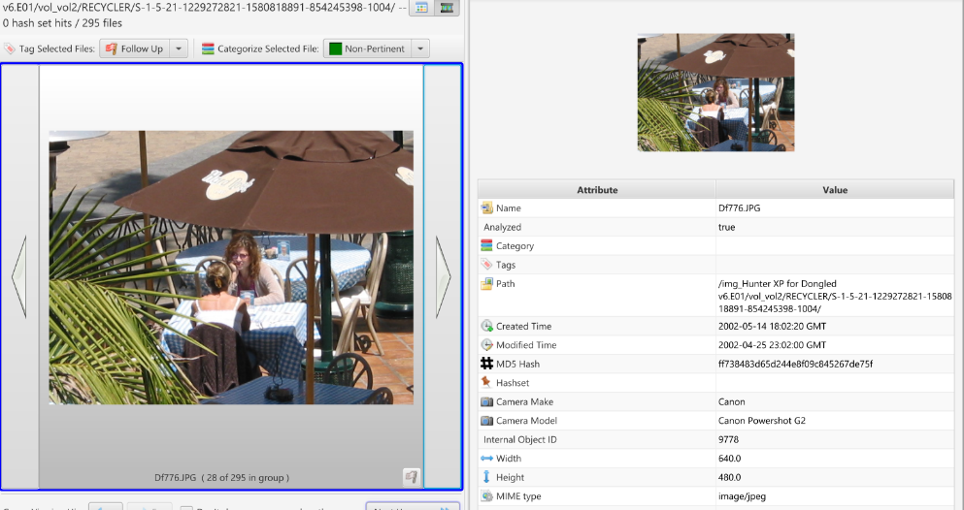
(Figure 6)

  - Reflection of the alleged stalker in Media Evidence
The suspect is visible in certain images, attempting to act as a street photographer.
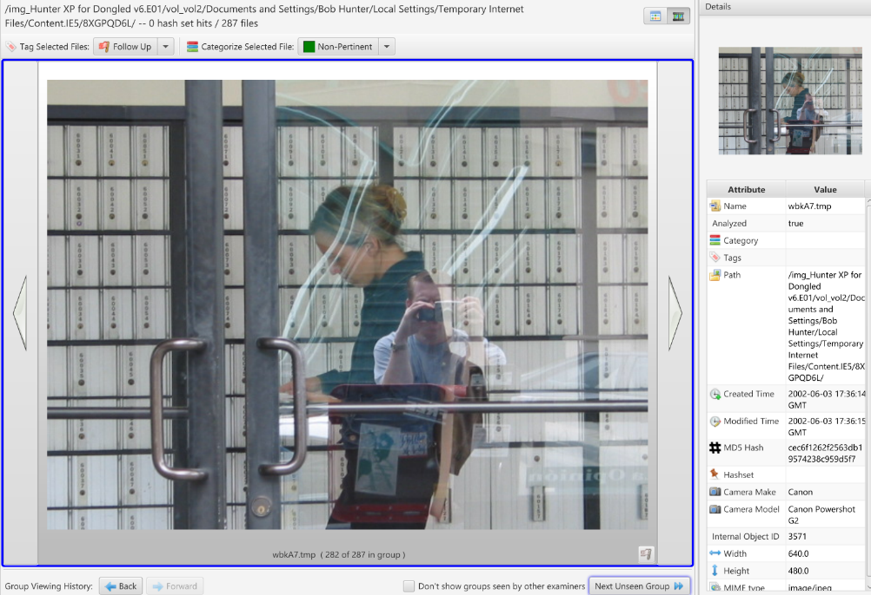
(Figure 7)

Alleged stalker sneaked a selfie with one of the victims.
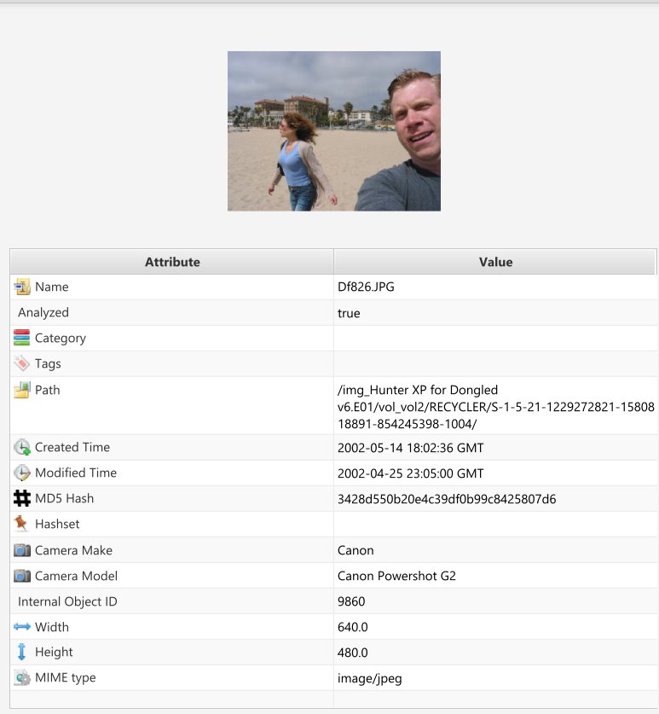
(Figure 8)

- Email Analysis

  - Analysis of Emails of the Alleged Suspect’s Email
- Suspect Email Accounts
- Chaser1191@hotmail.com
- Billyray120@hotmail.com

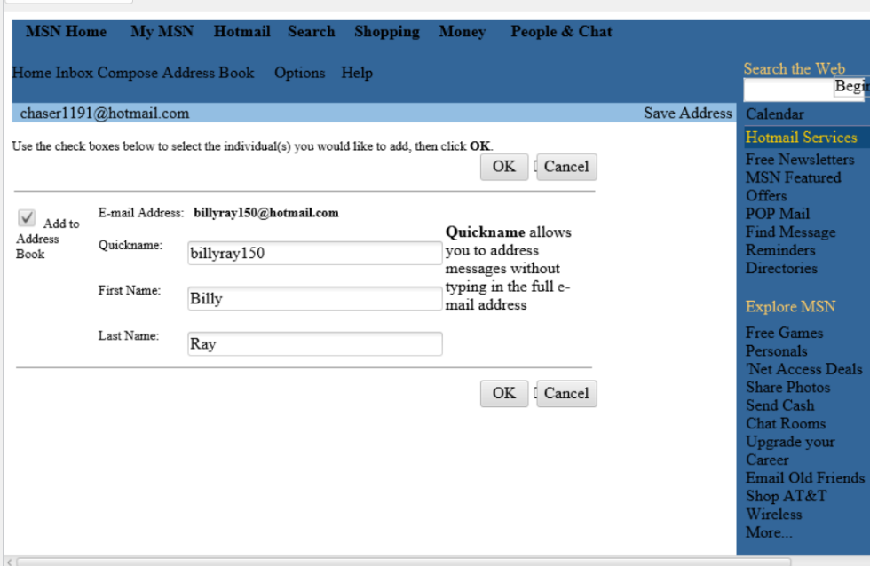
(Figure 9)

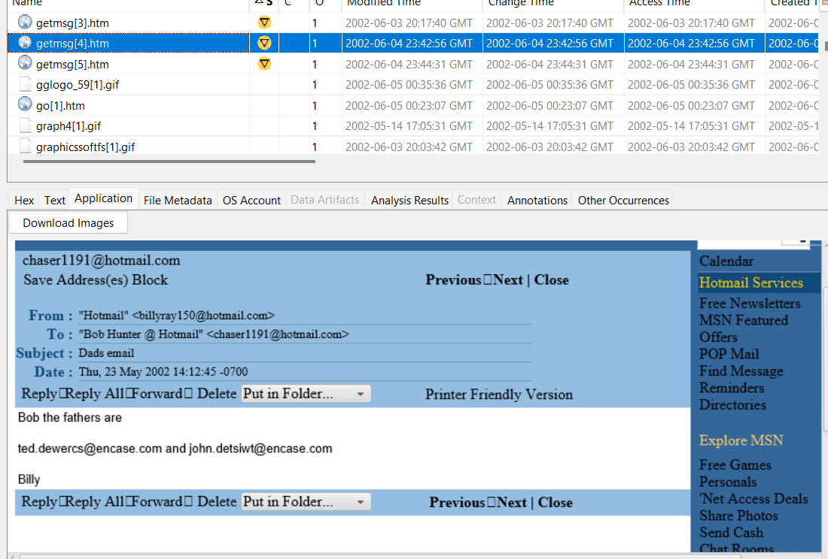

(Figure 10)
- The alleged stalker can be seen talking about the fathers of the victims.
- These accounts were reviewed for communication patterns, message content, and their metadata that could be in relation to other things within the system.
6.2 Analysis of Victim’s Email
- Victim Email Accounts
Emails related with Victims were also recovered and thoroughly examined.
- Ted.dewerce@encase.com
- John.detsiwt@encase.com
- Examination mainly focused on the timelines, headers and their relevance to the alleged crime.

  - Analysis of emails between suspect and victim.
- Emails sent by Christina’s father after the Suspect asked for ransom
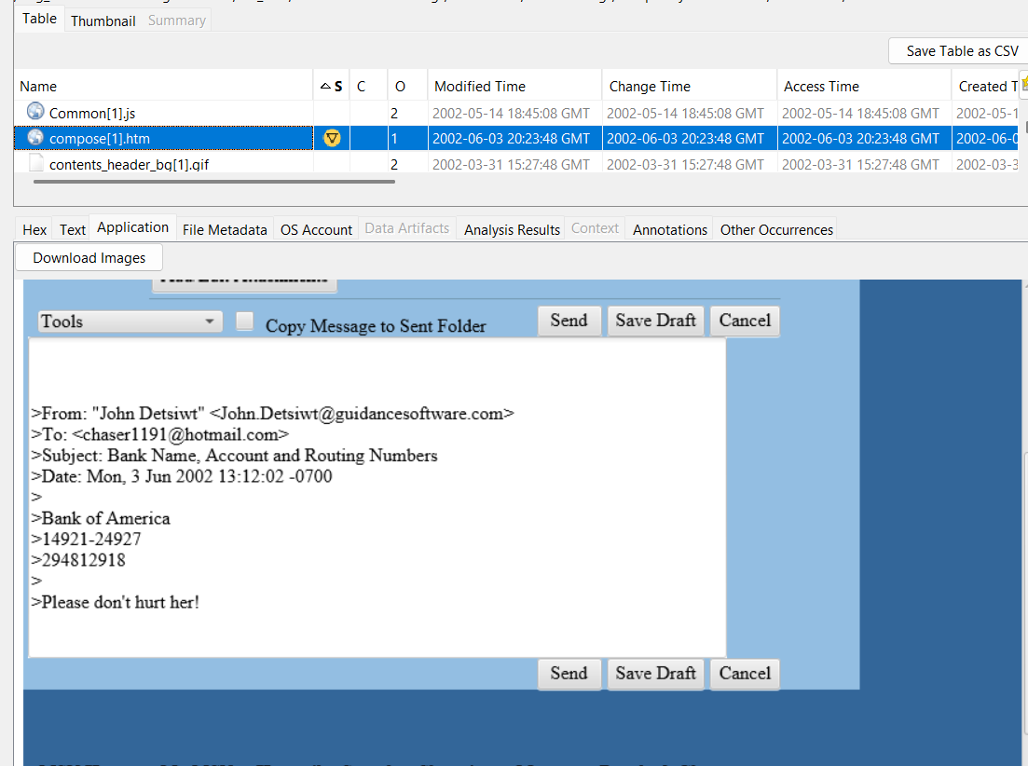
(Figure 11)

- Emails sent by Sabrina’s father after the Suspect asked for ransom.
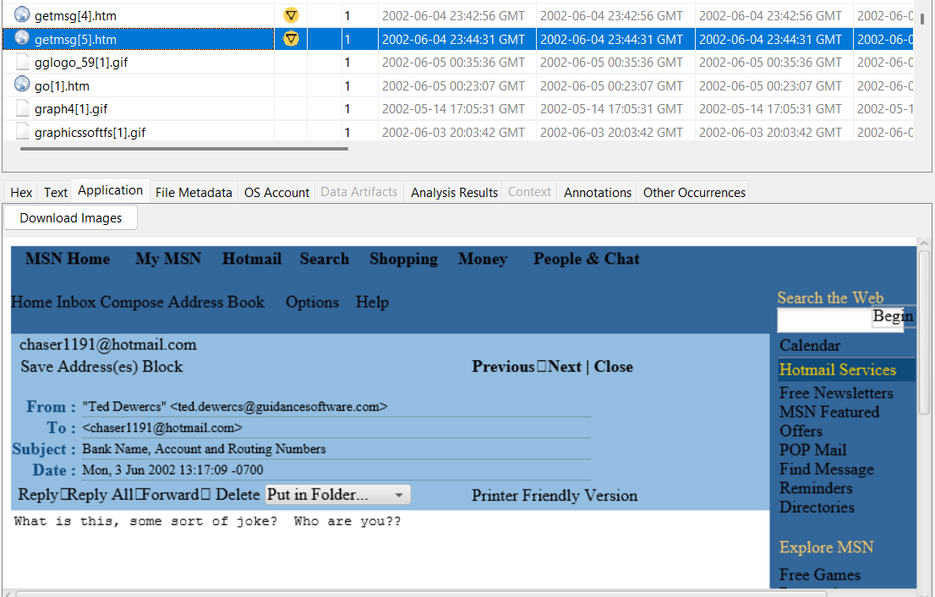
(Figure 12)
- Email communication that was recovered from the system showed the use of threatening language and demands for money, indicating attempts of extortion. The content in the mail shows that the communication was made with the intention of inducing fear and force compliance from the victim’s family for ransom.

- Instant messaging Tools Analysis.
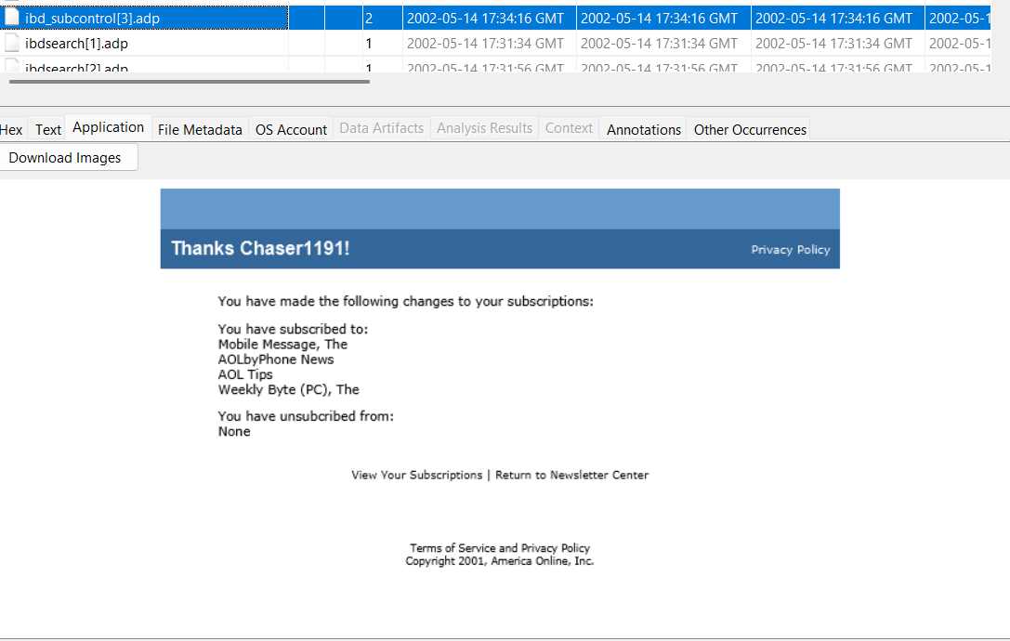
(Figure 13)

- Findings and Interpretation
The forensic analysis showed repeated use of system. Relation between OS artifacts, user account data, and communication-related activity supports that the system was used in connection with stalking and extortion-related activity.

The use of multiple forensic tools and evidence sources strengthens the reliability of the data and legal admissibility and decreases the misinterpretation.

- Conclusion
The forensic Examination of the Hunter XP for Dongled v6.E01_1 image file revealed a overwhelming amount of evidence supporting allegations of stalking, extortion, and conspiracy involving alleged crimes. Despite the continuous efforts in covering his tracks through deletion of data, recoverable data helped to reconstruct the time of events. The evidence that was identified is forensically conducted and suitable for further legal proceedings.

- Hash Verification
To make sure that the image file remains unaltered throughout the examination, hash verification was done prior to analysis and after too. Hash values were generated and verified (MD5 and SHAH256) using Autopsy. The calculated hash matched the verification values, confirming that the evidence file had not been tampered with during handling.

MD5 / SHA256: dfcfe9ab9a60c6ad4a314656b687226b / 1a50a99391857402131610299fa318a1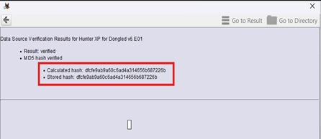
(Figure 14)

Hash verification is a basic forensic process which ensures the data integrity and supports the reliability and admissibility of the evidence. The validation of hash values shows that the analysis was done in a forensically sound environment.

- Appendices
- The forensic image Hunter XP for Dongled v6.E01_1 was analyzed using standard digital forensic tools.
- Autopsy was used for system analysis and timeline review.
- FTK Imager was used to extract registry data.
- Registry Viewer and RegRipper were used to examine OS and user related data.
- Event Log explorer supported the analysis of system event logs.
- Email accounts related to Suspect and victims were identified and reviewed.
- Image files linked to the alleged stalking were verified using metadata and hash values.
- The recovered images were Captured using a Canon PowerShot Camera.
- The reconstructed timeline was backed by registry data, logs and communication-related artifacts.
- Hash values were generated, before and after and then matched to confirm the integrity of the evidence.

